WEB DEVELOPMENT COURSES (WBC) PROJECT

Software Requirements Specification

|  |  |  |  |
| --- | --- | --- | --- |
|  | Prepared By | Reviewed By | Approved By |
| Name | Edulapuram Nishitha | Chandrasekar, Venkataraman |  |
| Role | Interns | Batch Trainer |  |

**Table of Contents**

Table of Contents…………………………………………………………..….......II

1. Introduction…………………………………………………………………..…1

1.1 Intended Audience……………………………………………….......1

1.2 Project Scope…………………………...……………………………1

2. Overall Description…………………………………………….……………….1

2.1 Operating Environment……………………...……………………....1

3. Requirements……………………………………………………………...…….1

3.1Login………………………………………………………………….2

3.1.1Description………………………………………………....2

3.1.2 Functional Requirements……..…………………………...2

3.1Login………………………………………………………………….2

3.1.1Description………………………………………………....2

3.1.2 Functional Requirements……..…………………………...2

**1. Introduction**

EMI Calculator is an online website. We are taking and testing three functionalities of that website (i.e.)

1. The EMI for Car with price of 15 Lac, Interest rate of 9.5% & Tenure 1 year; Display the interest amount & principal amount for one month  
2. From Menu, pick Home Loan EMI Calculator, fill relevant details & extract all the data from  year on year table & store in excel;  
3. From Menu, pick Loan Calculator and under EMI calculator, do all UI check for text box & scales; change the Loan tenure for year & month,check the change in scale; Re-use the same validation for Loan Amount Calculator & Loan Tenure Calculator.

**1.1 Intended Audience**

Business Unit (BU) SME

Academy coach

Technical Trainer

**1.2 Project Scope**

This document defines at a functional level the business activities that are encompassed by the system and the rules that apply to them. It also encompasses some of the key high and low level technical requirements of the system.

It draws heavily on both proposed Framework and Business Rules and the Technical Architecture documents. The scope of the detailed analysis project phase specifies that this document will include.

· Classification of requirements according to their functional areas.

· A description of each process in the system, including their inputs, outputs, and data transformation rules.

**2. Overall Description**

**2.1 Operating Environment**

Windows operating system

Web application

**3. Requirements**

This part of the requirements document serves to present the "Interest amount for current year" of the application and also we need to extract all the levels in Validation of transactions & do calculations, Extract table values & store in excel, Filling data in screen & multiple UI validations.

**3.1.1 Functional Requirements**

**3.1.1.1 Req0001**

**Req0001a-**The user navigates to car loan section.

**Req0001b**- The user enters the car loan amount as “15 lakhs”.

**Req0001c-**The user enters the Interest rate as “9.5%”.

**Req0001d-** The user enters the loan tenure as “1 year”.

**3.1.1.2 Req0002**

**Req0002a**- The user navigates to “Home Loan EMI Calculator”.

**Req0002b-** The user fills the relevant details.

**Req0002c-** The user extracts the data from year on year table to excel.

**3.1.2.3 Req0003**

**Req0003a**- The user navigates to EMI Calculator.

**Req0003b-** The user enters loan amount then the slider should be moved to the same given value.

**Req0003c-** The user enters Interest rate then the slider should be moved to the same given value.

**Req0003d-** The user enters loan tenure then the slider should be moved to the same given value.

**Req0003e-** The user enters month tenure then the slider should be moved to the same given value.

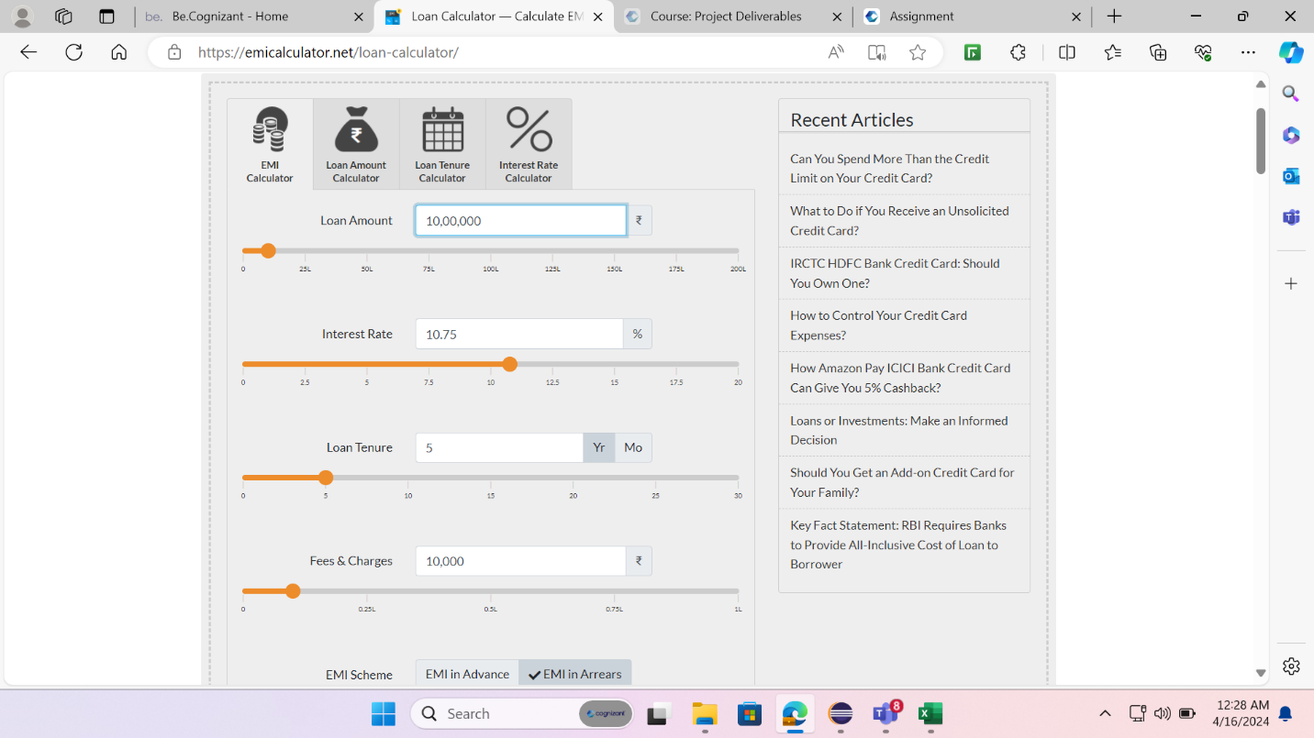

**3.1.2.4 Req0004**

**Req0004a**- The user navigates to loan amount Calculator.

**Req0004b-** The user enters EMI then the slider should be moved to the same given value.

**Req0004c-** The user enters Interest rate then the slider should be moved to the same given value.

**Req0004d-** The user enters loan tenure then the slider should be moved to the same given value.

**Req0004e-** The user enters fees charge then the slider should be moved to the same given value.

**3.1.2.4 Req0005**

**Req0005a**- The user navigates to loan tenure Calculator.

**Req0005b-** The user enters EMI then the slider should be moved to the same given value.

**Req0005c-** The user enters Interest rate then the slider should be moved to the same given value.

**Req0005d-** The user enters loan tenure then the slider should be moved to the same given value.

**Req0005e-** The user enters fees charge then the slider should be moved to the same given value.

